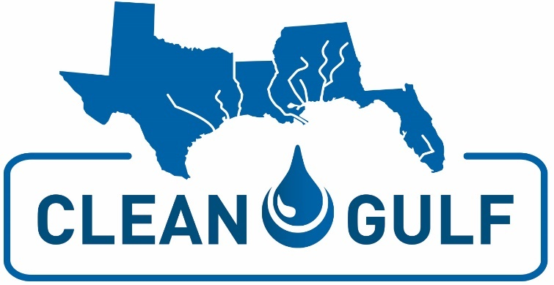

2020 CLEAN GULF CONFERENCE & EXHIBITION SAMPLE TRIP REPORT

Overview of Event:
The focus of CLEAN GULF was real-world best practices and lessons-learned for oil and hazardous materials prevention, preparedness and response.

The conference was structured over the course of three days offering workshops, keynote address, state and federal updates, and breakout sessions led by experts in industry and government. Ample time was given for networking before and after each session, allowing us to talk to the speakers and fellow attendees about the topics discussed
The Exhibit Hall was held onsite during the conference. All networking breaks were in the Exhibit Hall, allowing for multiple opportunities to visit with companies and investigate new products and services.
Summary of Conference Experience
During the conference, I was able to attend numerous sessions across multiple conference tracks. I focused on topics that directly relate to my position at <insert company>

Here are the sessions I found particularly insightful:
<Insert session title and speakers + brief description and any takeaways>
<Insert session title and speakers + brief description and any takeaways>
<Insert session title and speakers + brief description and any takeaways>
<Insert session title and speakers + brief description and any takeaways>
<Insert session title and speakers + brief description and any takeaways>
In addition to the conference sessions, the chance to network with other colleagues in similar situations was an extremely valuable experience. I was also able to interact with vendors in the Exhibit Hall at CLEAN GULF. The opportunity to research new solutions and discuss current technologies with service experts was very worthwhile and may provide cost-savings for <insert upcoming projects or purchases>
While at CLEAN GULF, I was able to attend the networking reception in the exhibit hall. This reception allowed me the opportunity to visit with vendors, speakers and other attendees.
<List specific people, vendors or speakers you interacted with and the benefits of those discussions.>
Conclusions
I was very pleased with my conference attendance and felt it was well worth the registration fee and travel expenses. I learned new solutions and best practice strategies that can be implemented in our facility/organization. In addition, I gained valuable experience that couldn’t be obtained anywhere else. The networking experience was very beneficial. I was able to speak with several industry experts who provided tips and useful information for my particular dilemmas and work projects.
The conference was very organized and the speakers provided candid opinions on the subject matter at hand, making the information extremely valuable. The Exhibit Hall provided a friendly, informative place to meet with vendors and view their products and services.
In addition, the meals and refreshment breaks were extremely nice and allowed me to save on my travel budget. I was very pleased with all that I received at CLEAN GULF and hope to attend again in 2020.

